**Ideation Phase**

**Brainstorm & idea Prioritization Template**

|  |  |
| --- | --- |
| **Team ID** | PNT2022TMID27681 |
| **Project Name** | SIGN WITH SMART CONNECTIVITY FOR BETTER ROAD SAFETY |
| **Maximum Marks** | 4 Marks |

**Brainstorm & Idea Prioritization Template:**

Brainstorming provides a free and open environment that encourages everyone within a team to participate in the creative thinking process that leads to problem solving. Prioritizing volume over value, out-of-the-box ideas are welcome and built upon, and all participants are encouraged to collaborate, helping each other develop a rich amount of creative solutions.

**Step-1: Team Gathering, Collaboration and Select the Problem Statement :**

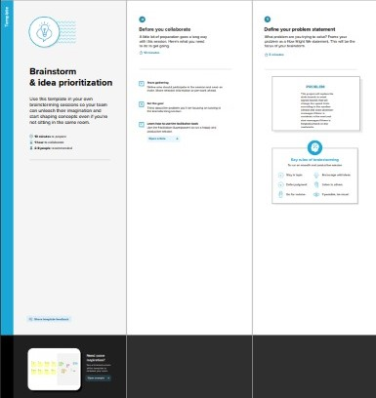

**Step-2: Brainstorm, Idea Listing and Grouping :**

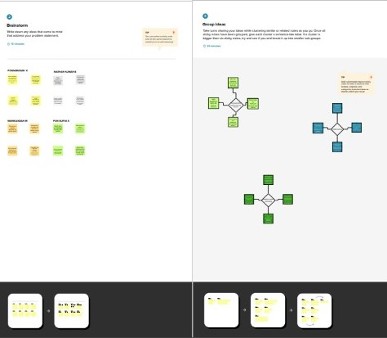

**Step-3: Idea Prioritization :**

